**Wild Fisheries Reform**

**Draft provisions for a Wild Fisheries (Scotland) Bill/ Draft Wild Fisheries Strategy**

**Strategic Environmental Assessment**

**Environmental Report**

**February 2016**



Marine Scotland

**Table of Contents**

[1 Introduction 1](#_Toc444095283)

[1.1 Introduction 1](#_Toc444095284)

[1.2 Strategic Environmental Assessment 1](#_Toc444095285)

[1.3 Report Purpose and Structure 1](#_Toc444095286)

[2 Wild Fisheries Reform 2](#_Toc444095287)

[2.1 Background 2](#_Toc444095288)

[2.2 Policy Context 2](#_Toc444095289)

[2.3 Draft Bill Provisions and Draft National Strategy 3](#_Toc444095290)

[The Draft Provisions of the Wild Fisheries (Scotland) Bill 3](#_Toc444095291)

[Scotland’s Draft National Wild Fisheries Strategy 7](#_Toc444095292)

[Policy and Plan Hierarchy 7](#_Toc444095293)

[3 Approach to SEA 10](#_Toc444095294)

[3.1 Background 10](#_Toc444095295)

[3.2 Scope of the Draft Bill Provisions and National Strategy 10](#_Toc444095296)

[3.3 Scope of the Assessment 11](#_Toc444095297)

[3.4 Reasonable Alternatives 11](#_Toc444095298)

[3.5 Assessment Methodology and Reporting 15](#_Toc444095299)

[3.6 Identifying monitoring proposals 15](#_Toc444095300)

[4 Environmental Baseline 16](#_Toc444095301)

[4.1 Biodiversity 16](#_Toc444095302)

[Policy Context 16](#_Toc444095303)

[Freshwater Fish 16](#_Toc444095304)

[Other Freshwater Species 19](#_Toc444095305)

[Designations 19](#_Toc444095306)

[4.2 Water 22](#_Toc444095307)

[Policy Context 22](#_Toc444095308)

[River Basin Management Plans 22](#_Toc444095309)

[Ecological Status of Rivers and Lochs 23](#_Toc444095310)

[4.3 Human Health 26](#_Toc444095311)

[Policy Context 26](#_Toc444095312)

[General 26](#_Toc444095313)

[Angling/ Angler Activity 28](#_Toc444095314)

[5 Existing Environmental Pressures 29](#_Toc444095315)

[5.1 Salmon and Sea Trout 29](#_Toc444095316)

[5.2 Non-migratory Salmonids/Other Freshwater Fish Species 29](#_Toc444095317)

[6 Fisheries Management 32](#_Toc444095318)

[6.1 Introduction 32](#_Toc444095319)

[6.2 Catchment Level Management 32](#_Toc444095320)

[6.3 Fisheries Management at the Local Level 35](#_Toc444095321)

[6.4 Environmental Effects of Fisheries and Habitat Management and Practices 37](#_Toc444095322)

[7 Environmental Effects 40](#_Toc444095323)

[7.1 Introduction 40](#_Toc444095324)

[7.2 Draft Bill Provisions 40](#_Toc444095325)

[Biodiversity 40](#_Toc444095326)

[Water 42](#_Toc444095327)

[Human Health 42](#_Toc444095328)

[7.3 Draft National Strategy 42](#_Toc444095329)

[Vision 42](#_Toc444095330)

[Key Overarching Objectives 43](#_Toc444095331)

[Strategic Framework 43](#_Toc444095332)

[8 Conclusions, Consultation and Next Steps 47](#_Toc444095333)

[9 References 48](#_Toc444095334)

[10 Appendix 1: Draft Bill Provisions Screening 50](#_Toc444095335)

1. Introduction
   1. Introduction
      1. Scottish Ministers propose to introduce a new system for wild fisheries management in Scotland. Broad policy options for a new management structure were consulted on between May and August 2015, and work with stakeholders has continued to develop the new system further.
      2. The Scottish Government is now consulting on draft provisions for inclusion in a future Wild Fisheries (Scotland) Bill and on an outline draft Wild Fisheries Strategy (the “draft policy instruments”).
   2. Strategic Environmental Assessment
      1. The Environmental Assessment (Scotland) Act 2005 requires the assessment of certain plans, programmes and strategies (including policy) that may have significant effects on the environment. As the Scottish Government considers that the draft policy instruments may give rise to significant environmental effects, a strategic environmental assessment (SEA) of the draft Bill and national strategy has been undertaken.
   3. Report Purpose and Structure
      1. The purpose of this Environmental Report is to set out the results of the SEA.
      2. The remainder of this report is structured as follows:

* Following this introductory section, Section 2 provides background information about the Wild Fisheries Reform process and then goes on to briefly outline the contents of the draft Bill provisions and outline draft national strategy.
* Section 3 sets out the approach to the SEA.
* Section 4 describes the characteristics of the existing environment for biodiversity, human health, and the water environment.
* Section 5 describes existing pressures on freshwater migratory and non-migratory species.
* Section 6 provides information about existing fisheries management systems and practices.
* Section 7 sets out the predicted environmental effects of the draft Bill provisions and national strategy, including cumulative effects.
* Section 8 sets out the conclusions and outlines the next steps in the process.
* Supporting information is provided in the appendix.

1. Wild Fisheries Reform
   1. Background
      1. The Scottish Government has a manifesto commitment (2011) to support and protect Scotland’s salmon and freshwater fisheries and to modernise the management framework. The first stage in delivering this commitment was to update the governance of salmon fisheries via the Aquaculture and Fisheries (Scotland) Act 2013. The second stage was to commission an independent Wild Fisheries Review to consider the requirements of a modern, evidence-based management system for all of Scotland’s wild fisheries. The Review Panel reported in October 2014[[1]](#footnote-1) and made 53 recommendations for change which, taken together, would result in a fundamental re-design of the existing fishery management system.
      2. The Review Panel also recommended urgent action by the Scottish Government to improve regulation of the killing of wild Atlantic salmon. Marine Scotland consulted (6 February-30 April 2015) on proposed conservation measures to: introduce a ban on killing wild salmon except under licence; make associated baits and lures regulations; and introduce carcass tagging to support enforcement of the licensing system.
      3. The next step was to consult[[2]](#footnote-2) (May-August 2015) on broad policy options for a new management system, covering:

* roles and responsibilities at national and local levels.
* proposals for local management bodies.
* resourcing of wild fisheries management, including a wild fisheries levy.
* sustainable harvesting, i.e. powers for Ministers to control harvesting of all wild fish species on conservation grounds.
* science and skills, including data collection priorities and processes and skills development.
* regulation and compliance.
* opportunities and access, including leadership within the angling sector; widening opportunities and access; and “Angling for All”.
  + 1. Over 200 written responses to the consultation were received[[3]](#footnote-3), alongside feedback from numerous public and stakeholder meetings.
  1. Policy Context
     1. The current legislative and policy context for the draft Bill provisions and national strategy is set out in Figure 2.1. This covers:
* European legislation and international conventions (in green)
* UK and Scottish legislation (in orange)
* Scottish policy (in blue)
* relevant reports (in pale blue)
  1. Draft Bill Provisions and Draft National Strategy
     1. *A Stronger Scotland: the Government’s Programme for Scotland 2015-16*[[4]](#footnote-4) commits Scottish Ministers to consult on draft provisions for a Wild Fisheries Bill before the end of the current parliamentary session (this consultation).
     2. The draft Bill provisions and draft outline national strategy build on the contents of the summer 2015 consultation document and the responses received through the consultation process, together with the results of work with stakeholders i.e. the Stakeholder Reference Group and the Strategy Development Group[[5]](#footnote-5).

The Draft Provisions of the Wild Fisheries (Scotland) Bill

* + 1. The draft provisions of the Wild Fisheries (Scotland) Bill cover the following:
* administration and management of wild fisheries (Part 1). This part sets out national and local arrangements, including: Scottish Ministers’ powers and responsibilities; the process for establishing Fisheries Management Organisations (FMOs); a series of good governance requirements; and provision for a wild fisheries levy.
* regulation of wild fishing and fisheries (Part 2). This part establishes the regulatory framework, including: prescribing the methods of fishing which are allowable; powers to create conservation measures for all species of freshwater fish; control on fishing; and a power to create a licensing scheme.
* enforcement (Part 3). This part sets out the measures to enforce the legislation, in terms of the appointment process and powers of water bailiffs and fishery wardens.
* general matters (Part 4). This part defines certain terms for the purposes of the provisions.

Descriptions of each section are provided in Table 2.1.

* + 1. The draft provisions do not represent a draft Bill in its entirety:
* Further work will be undertaken to explore the funding of freshwater fisheries management, including an online dialogue.
* Provisions relating to technical issues, such as offences and authorisations for introductions and activities which would otherwise be illegal (such as electrofishing), are still under development (Part 2).
* Provisions relating to the powers of enforcement officers are still under development (Part 3).
* Provisions relating to the transitional arrangements, in moving from the current system to the future system, will be developed.
  + - * 1. Legislation and Policy Context for draft Bill provisions and National Strategy

Directive 2000/60/EC

Water Framework Directive

Directive 2008/56/EC

Marine Strategy Framework Directive

Directive 1992/43/EEC

Habitats Directive

Convention for the Conservation of Salmon in the North Atlantic Ocean

National Marine Plan

SG policy agendas/activities: Land Reform; Biodiversity Strategy; River Basin Management Planning

Wild Fisheries Review (2014)

One Scotland: The Government’s Programme for Scotland

2014-15

Proposed Ban on Killing Wild Salmon Except Under Licence

**Wild Fisheries Reform**

**draft Bill provisions and**

**National Strategy**

Marine Scotland Science Report 3/14 “Status of Scottish Salmon and Sea Trout Stocks 2013” (2014)

A Strategic Framework for Scottish Freshwater Fisheries (2008)

Conservation of Salmon (Annual Close Time and Catch and Release) (Scotland) Regulations 2014

The Freshwater Fish Conservation (Prohibition on Fishing for Eels) (Scotland) Regulations 2008

The Conservation of Salmon (Prohibition of Sale) (Scotland) Regulations 2002

The Sea Fish Conservation Act 1967

The Inshore Fishing (Scotland) Act 1984

Aquaculture & Fisheries (Scotland) Act 2013

Salmon and Freshwater Fisheries (Consolidation) (Scotland) Act 2003

NASCO Implementation Plan 2013-18 EU – UK (Scotland)

The Scotland Act 1998 (River Tweed) Order 2006

The Scotland Act 1998 (Border Rivers) Order 1999

Nature Conservation (Scotland) Act 2004

Wildlife and Countryside Act 1981 (as amended)

Marine (Scotland) Act 2010

Water Environment (Controlled Activities) (Scotland) Regulations 2011 as amended

* + - 1. Draft Bill Provisions: Contents

| **Section** | **Proposed powers/duties** |
| --- | --- |
| *Part 1: Administration and Management of Wild Fisheries* | |
| 1 | Scottish Ministers’ overarching duty to promote: the conservation of freshwater fish in wild fisheries and their habitats; and best practice in the management of wild fisheries. |
| 2 | Requires Scottish Ministers to prepare a national strategy; to consult; and to lay the strategy before the Scottish Parliament. The strategy will set out Scottish Ministers’ objectives, priorities and policies for: the conservation of freshwater fish in wild fisheries and their habitats; and the management of wild fisheries. |
| 3 | Sets out the process by which the strategy should be reviewed (on a five-year cycle) and, if appropriate, revised. |
| 4 | Powers for Scottish Ministers to undertake research or inquiries into any matter relating to or affecting wild fisheries and/or freshwater fish in wild fisheries; and to obtain information about these matters. |
| 5 | Allows Scottish Ministers to sample or tag fish for identified purposes e.g. research. |
| 6 | Places a duty on Scottish Ministers to divide Scotland into areas, to be known as Fisheries Management Areas. |
| 7 | Identifies estuary limits for rivers in a Fisheries Management Area. |
| 8 | Sets out the process by which Fisheries Management Organisations (FMOs) will be designated. |
| 9 | Duty of a FMO to promote: the conservation of freshwater fish in wild fisheries in its Area and their habitats; and best practice in the management of those wild fisheries. In discharging that duty, to act in accordance with the National Wild Fisheries Strategy and the Local fisheries Management Plan for its Area. |
| 10 | Duty on a FMO to prepare a Local Fisheries Management Plan and submit the plan to Scottish Ministers for approval. The Local Fisheries Management Plan will set out FMOs’ objectives and priorities with respect to: the management of wild fisheries in its Area; the conservation of freshwater fish in those areas and their habitats; and the activities to be undertaken. |
| 11 | Requires FMOs to prepare and publish annual reports. |
| 12 | Requires FMOs to prepare and publish annual audited accounts. |
| 13 | Sets out requirements for FMOs to hold an annual public meeting. |
| 14 | Sets out requirements for a complaints procedure. |
| 15 | Effect of governance requirements under other legislation. |
| 16 | Powers to Scottish Ministers to modify the governance requirements. |
| 17 | Powers to Scottish Ministers to issue guidance to FMOs about governance. Duty on FMOs to have regard to such guidance. |
| 18 | Powers to Scottish Ministers to investigate FMOs. |
| 19 | Powers to Scottish Ministers following such investigations. |
| 20 | Allows a decision by Scottish Ministers to revoke a FMO’s designation to be reviewed by an independent person. |
| 21 | Powers to Scottish Ministers to provide financial assistance to a FMO. |
| 22 | Sets out the framework for a wild fisheries levy. |
| *Part 2: Regulation of Wild Fishing and Fisheries* | |
| 23 | Power to Scottish Ministers to make conservation regulations for or about the conservation of freshwater fish and/or their habitats, as well as for the protection and management of wild fisheries. |
| 24 | Provision for such regulations to control, amongst others, fishing methods, equipment, locations, timing, catch and release, etc. including prohibition on returning dead fish to the water. |
| 25 | Provision for such regulations to make provision for or about:   * construction/alteration of structures in the water e.g. dams; * alteration/removal of natural obstructions in rivers/estuaries; * alteration of watercourses; or * protection of fish from predators, parasites or disease. |
| 26 | Provision for collecting data and evaluating information. |
| 27 | Provision for tagging fish. |
| 28 | Provision for licensing schemes for the taking and killing of freshwater fish. |
| 29 | Duty on Scottish Ministers to consult affected FMOs and others as appropriate before making such regulations, unless these have been requested by the FMO in question. |
| 30 | Process for FMOs to make requests for local measures. |
| 31 | Where FMOs have made such a request, duty for FMO to monitor and evaluate the effectiveness of local measures. |
| 32 | Sets out offence of contravention of conservation regulations. |
| 33 | Makes it a criminal offence to fish for, take or kill any species of fish without legal right of permission. |
| 34 | With Schedule 1, prescribes lawful methods of fishing for or taking freshwater fish. |
| *Part 3: Enforcement* | |
| 35 | Powers to FMOs and Scottish Ministers to appoint water bailiffs. |
| 36 | Exercise of enforcement powers |
| 37 | Powers of enquiry |
| 38 | Powers of entry |
| 39 | Wardens |
| 40 | Exercise of enforcement powers |
| 41 | Powers of enquiry and entry |
| *Part 4: General* | |
| 42 | Fish and fisheries: definitions |
| 43 | Conservation and management: definitions |
| 44 | Other definitions and interpretation |
| 45 | Border rivers: the Act would not apply to the River Tweed or the Upper Esk. |

Scotland’s Draft National Wild Fisheries Strategy

* + 1. The outline draft national strategy aims to provide:
* a long-term vision for managing and developing wild freshwater fisheries in Scotland (Table 2.2);
* an outline methodology for achieving that vision (in the form of a Governance and Accountability Framework); and
* a structure for greater stakeholder involvement in the development and management of wild fisheries in Scotland.
  + - 1. Vision for Managing and Developing Scotland’s wild fisheries

|  |
| --- |
| *To protect, develop and enhance social and economic benefit from Scotland’s freshwater fish and fisheries; and to promote access to fishing opportunities and participation.* |

* + 1. At this early stage, the outline draft strategy comprises:
* the afore-mentioned vision;
* key overarching objectives (Table 2.3); and
* a strategic framework to assist the delivery of the objectives. This comprises four themes, for which indicators and associated activities have been identified. More detail is provided in Table 2.4.
  + - 1. Key Overarching Objectives

|  |
| --- |
| * *Providing comprehensive protection and improvement of Scottish freshwater fish and the habitats they depend on.* * *Promoting effective, evidence-based fishery management through integrated data gathering, research and dissemination.* * *Identifying and maximising societal benefits from sustainable fisheries, and the promotion of angling as a recreational and tourism activity.* |

Policy and Plan Hierarchy

* + 1. The policy and plan hierarchy will be as follows:
* the Wild Fisheries Strategy, providing overarching national priorities at the strategic level;
* a comprehensive national management plan, setting out clear and time-limited nationally prioritised actions;
* local fisheries management plans, setting out clear and time-limited regionally prioritised actions.
  + 1. This hierarchy is not intended to act as a “top down” system; rather, there will be interaction and sharing of information between all levels in the preparation of strategies and plans, and in monitoring and evaluating their implementation.
       1. Draft National Strategy: Strategic Framework

| **No.** | **Indicator** | **Associated activities** |
| --- | --- | --- |
| ***Theme 1: Protecting and growing the resource*** | | |
| 1.1 | National approach to the protection and restoration of habitats | * Identify pressures on fish, their habitats and species and prioritise and take pragmatic action where sensible. * Integrate with existing national and regional processes, including River Basin Management Planning, Habitats Directive objectives and the National Planning Framework. |
| 1.2 | Identification of national and local priorities for fisheries management through a coordinated system of management and conservation plans | * Production of a comprehensive national management plan setting out clear and time-limited nationally prioritised actions. * Fishery management plans will set out clear and time-limited regionally prioritised actions. * Guidance on the optimisation of stocks for all species. |
| 1.3 | National Enforcement Regime | * Maintenance of a professionally recognised Scotland wide fishery enforcement officer role (and support services) with specific responsibilities and accountability for ensuring compliance with relevant legislation. * Foster interaction with wider enforcement bodies and develop a partnership approach. * Continuous professional development with access to relevant training and learning opportunities. * Promotion of greater public awareness and confidence with the profession. |
| ***Theme 2: Science and research*** | | |
| 2.1 | Memorandum of understanding defining the relationship between national and local science, including an agreed approach to the coordination and planning of research projects and priorities. | * Acceptable operating standards * Principles of information archiving * Principles of access to information * Principles of science coordination and planning |
| 2.2 | Establish research and data collection priorities to meet local, national and international needs, to be reviewed and updated as part of the fishery management planning cycle. | * Identify key knowledge gaps hindering effective management. * Develop a science delivery programme with partners to address knowledge gaps. * Ensure the Scottish Government is able to demonstrate that it is meeting or progressing towards achieving its international obligations. * Development of citizen science activities to empower wider participation, with the emphasis on transparency and openness. |
| 2.3 | Scottish national standards for the collection, storage, analysis, access, publication and use of data. | * Set standards for appropriate training to promote consistent standards. * Ensure appropriate analysis. * Ensure data is publicly available and accessible. * Audit compliance with standards. |
| ***Theme 3: Partnership and Engagement*** | | |
| 3.1 | Partnership working. | * Further the partnership working already established between policy makers, stakeholders, and delivery agents for fisheries. * Detailed expectations around engagement at a local and national level, both within and outwith the sector. * Development of opportunities for collaborative working. |
| 3.2 | Policy development. | * Interaction between policy makers, stakeholders and the science community to facilitate focused research and evidence based policy development. |
| ***Theme 4: Promotion*** | | |
| 4.1 | Marketing and promoting opportunities for angling across Scotland. | * Promote angling to stakeholders of all ages. * Joined up approach to education and the promotion of classroom-based activities designed to encourage and provide young anglers with a basic understanding of fish and the wider environment. * Develop and provide guidance for angling clubs on how best to encourage youth participation. * Develop and provide guidance on the concept of responsible access to angling for all species and fisheries management best practice in Scotland. * Liaise with all relevant interests on the development and promotion of a national and local angling tourism strategy. * Development plan with angling businesses to better understand the needs of anglers and to improve the associated facilities and infrastructure. * Positive community role – recognition of fisheries as a positive contribution to the communities of Scotland. |

1. Approach to SEA
   1. Background
      1. The Scottish Government considers that the draft Bill provisions and outline draft national strategy fall under Section 5(4) of the Environmental Assessment (Scotland) Act 2005 (“the Act”).
      2. A screening exercise was carried out to ascertain whether strategic environmental assessment (SEA) of the draft policy instruments should be undertaken. Based on the evaluation against the screening criteria (Schedule 2 of the Act), it was concluded that they would likely give rise to significant environmental effects. The next step was to undertake a scoping exercise, to identify the scope and level of detail of the SEA.
      3. A joint screening and scoping report was submitted to the Consultation Authorities: Scottish Environment Protection Agency (SEPA), Scottish Natural Heritage (SNH), and Historic Environment Scotland (HES). All three agreed that significant environmental effects were likely and provided helpful comments on the scope and level of detail of the SEA.
   2. Scope of the Draft Bill Provisions and National Strategy
      1. The draft national strategy applies to the whole of Scotland. The draft Bill provisions apply to the whole of Scotland, with the exception of the River Tweed and the Upper Border Esk. These border rivers are subject to separate legislative regimes created under the Scotland Act 1998 to allow a whole-river management system across Scotland and England. For the Tweed, the Scotland Act 1998 (River Tweed) Order 2006 confers functions on the Scottish Ministers and the River Tweed Commission. Any changes to the management system for the River Tweed, to maintain the current alignment with the rest of Scotland, will require a new or updated Tweed Order in due course. The Upper Border Esk is subject to bye-laws made by the Environment Agency by virtue of the Scotland Act 1998 (Border Rivers) Order 1999, and will continue to be managed by the Environment Agency.
      2. The focus of both the draft Bill provisions and the draft national strategy is on inland and coastal waters (within 5 kilometres seaward from mean low water springs)[[6]](#footnote-6). The new system applies to rivers and lochs as well as put-and-take fisheries in still waters.
      3. The proposed FMO structure would manage all freshwater fish species, including migratory and non-migratory salmonids and coarse fish.
      4. The powers and duties to be set out in the draft Bill will be phased in once the Bill receives royal assent, to ensure a smooth transition between the current and new management structures. The national strategy will be subject to periodic review, possibly on a five-year cycle.
      5. The draft Bill provisions have been subject to a screening exercise, so that the SEA can focus on those with the potential for significant effect. The results are set out in Appendix 1; the provisions to be assessed by the SEA are set out in Table 3.1. (Note that this table identifies the potential environmental effects; a fuller discussion is provided in Section 7 of this report.) A similar exercise was carried out for the draft strategy; all the contents were screened into the SEA.
   3. Scope of the Assessment
      1. The scope of the SEA reflects the geographical and temporal scope of the draft Bill provisions and national strategy.
      2. Schedule 3 of the Act sets out the environmental factors that may be included in the scope of the SEA. An initial review of the potential environmental effects of the draft policy instruments identified the following:

* the potential benefits to human health, through increased access to and participation in outdoor recreation;
* the continuing benefit to biodiversity, flora and fauna – including but not limited to freshwater fish species – resulting from habitat management activities, species conservation activities and so on. There may also be benefits from seeking to apply freshwater fisheries management across the whole of Scotland, and to all freshwater fish species.
* possible benefits to water quality and resources, including the ecological potential of water bodies, from improved communications and integration of activities between the different agencies, organisations and stakeholders involved in freshwater fisheries and catchment management activities. This would build on the good work already being undertaken through involvement in, e.g. river basin management planning, forestry planning etc.
  + 1. The scoping exercise confirmed that the draft policy instruments could affect the following: biodiversity, flora and fauna; water, in terms of water quality and the ecological status of water bodies; soil, geology and hydrodynamic processes, in terms of water and sediment quality; and human health, in terms of improved access to and participation in recreation. These environmental factors were therefore scoped into the SEA, and the remaining factors scoped out. The rationale for this approach is provided in Table 3.2.
  1. Reasonable Alternatives
     1. No reasonable alternatives to the contents or wording of the draft Bill provisions were identified as mitigation measures by the SEA. Some alternative wording for the contents of the draft national strategy has been suggested as part of the identification of mitigation measures (see Section 7 of this report).
        1. Draft Bill Provisions Screened in to SEA

| **Section** | **Proposed powers/duties** | **Potential for environmental effect?** |
| --- | --- | --- |
| 1 | Scottish Ministers’ overarching duty to promote: the conservation of freshwater fish in wild fisheries and their habitats; and best practice in the management of wild fisheries. | Yes. Management practices are likely to be beneficial for aquatic ecosystems, as well as freshwater fish species. However, some management practices may adversely affect other aspects of aquatic and terrestrial ecosystems (see Section 6 of this report). |
| 2 | Requires Scottish Ministers to prepare a national strategy; to consult; and to lay the strategy before the Scottish Parliament. The strategy will set out Scottish Ministers’ objectives, priorities and policies for: the conservation of freshwater fish in wild fisheries and their habitats; and the management of wild fisheries. |
| 3 | Sets out the process by which the strategy should be reviewed (on a five-year cycle) and, if appropriate, revised. | Uncertain. The review of the strategy would assist its updating if monitoring identified unanticipated or adverse environmental effects, or benefits that could be enhanced. |
| 6 | Places a duty on Scottish Ministers to divide Scotland into areas, to be known as Fisheries Management Areas. | Yes. Extends fisheries management to all of Scotland, as well as to all freshwater fish species. |
| 9 | Duty of a FMO to promote: the conservation of freshwater fish in wild fisheries in its Area and their habitats; and best practice in the management of those wild fisheries. In discharging that duty, to act in accordance with the National Wild Fisheries Strategy and the Local fisheries Management Plan for its Area. | Yes. Management practices are likely to be beneficial for aquatic ecosystems, as well as freshwater fish species. However, some management practices may adversely affect other aspects of aquatic and terrestrial ecosystems. |
| 10 | Duty on a FMO to prepare a Local Fisheries Management Plan and submit the plan to Scottish Ministers for approval. The Local Fisheries Management Plan will set out FMOs’ objectives and priorities with respect to: the management of wild fisheries in its Area; the conservation of freshwater fish in those areas and their habitats; and the activities to be undertaken. |
| 22 | Sets out the framework for a wild fisheries levy. | Uncertain. Stakeholders have raised concerns about costs being passed on to anglers, with potential adverse effects on human health. |
| 23 | Power to Scottish Ministers to make conservation regulations for or about the conservation of freshwater fish and/or their habitats, as well as for the protection and management of wild fisheries. | Yes. Would continue existing powers to make certain fisheries management practices statutory, e.g. close times, equipment types, fishing methods, etc. |
| 24 | Provision for such regulations to control, amongst others, fishing methods, equipment, locations, timing, catch and release, etc. including prohibition on returning dead fish to the water. |
| 25 | Provision for such regulations to make provision for or about:   * construction/alteration of structures in the water e.g. dams; * alteration/removal of natural obstructions in rivers/estuaries; * alteration of watercourses; or * protection of fish from predators, parasites or disease. | Yes. Would contribute to the resolution of catchment-wide pressures on freshwater fish and their habitats. |
| 26 | Provision for collecting data and evaluating information. | Yes. The collection of data would support the evidence base needed for appropriate fisheries management strategies and practices. |
| 27 | Provision for tagging fish. | Yes. Controls taking and killing of freshwater fish – important for rivers where population levels are not sustainable. |
| 28 | Provision for licensing schemes for the taking and killing of freshwater fish. |
| 36 | Exercise of enforcement powers | Yes. Supports enforcement of regulations whose objective is to protect and/or conserve freshwater fish. |

* + - 1. Scoping In / Out of SEA Topics

| **SEA Topic** | **In/out** | **Reasons for inclusion / exclusion** |
| --- | --- | --- |
| Biodiversity, flora and fauna | In | The continuing benefit to and potential enhancement of biodiversity, flora and fauna – including but not limited to freshwater fish species – resulting from habitat management activities, species conservation activities and so on. There may also be benefits from seeking to apply freshwater fisheries management across the whole of Scotland, and to all freshwater fish species. |
| Population | Out | The draft policy instruments would not result in e.g. significant increases and/or decreases in human population numbers, changes to in- or out-migration, etc. |
| Human health | In | One of the themes of the draft national strategy is to encourage increased participation in and access to angling. This would benefit human health and well-being in terms of improved access to and participation in recreation. |
| Soil, geology and hydrodynamic processes | In | There may be benefits to sediment quality and the beds of water bodies, through improvement of water quality. These have been considered under the ecological status of water bodies and discussed under “biodiversity” and “water”. |
| Water quality, resources, ecological status | In | Possible benefits to water quality and resources, including the ecological status of water bodies, from improved communications and integration of activities between the different agencies, organisations and stakeholders involved in freshwater fisheries and catchment management activities. This would build on the good work already being undertaken through involvement in, e.g. river basin management planning, forestry planning etc. |
| Air | Out | Freshwater fisheries management would be unlikely to result in emissions to air. |
| Climatic factors | Out | Freshwater fisheries management would not result in increased/ decreased emissions of greenhouse gases. |
| Material assets | Out | Freshwater fisheries management is unlikely to affect material assets depending on environmental quality, other than fisheries. The SEA considers the effects on those environmental factors underpinning freshwater fisheries – biodiversity, flora and fauna and water quality, resources and ecological status. To avoid duplication, material assets have been scoped out. |
| Cultural heritage | Out | Freshwater fisheries management does not have the potential to affect historic environment assets, including underwater marine archaeological features. |
| Landscape/ seascape | Out | Freshwater fisheries management is unlikely to have effects on landscape and/or seascape. |

* 1. Assessment Methodology and Reporting
     1. Given the nature of the draft policy instruments, no spatial effects at the national level were anticipated. Given the high-level nature of the draft instruments and the potential environmental effects, the SEA was carried out using a set of SEA objectives (Table 3.3) based on the environmental topics identified in Table 3.1. This has included identifying the potential environmental effects of fisheries management activities and/or habitat management practices (both positive and negative) to ensure that mitigation for these is captured in the policy/plan hierarchy. The effects have been assessed using the categories set out in Table 3.4.
     2. The results of the assessment are provided in a narrative style, centred on exploring the issues raised. This narrative approach provides explanatory text to support the findings of the assessment, and records the evidence used in reaching its conclusions and recommendations.
     3. The SEA has built on and updated existing information collected through the SEA of the proposed salmon conservation measures. It has also taken into account information provided by respondents to consultations
        1. SEA Objectives

| SEA Topics | Will the proposed conservation measures … |
| --- | --- |
| Biodiversity, flora and fauna | * safeguard aquatic ecosystems, including species and habitats, and their interactions? * maintain or work towards good ecological status? |
| Water |
| Human health | * provide opportunities for physical activity, to the benefit of human health? |

* + - 1. Assessment Categories

|  |  |
| --- | --- |
| Work against SEA objectives |  |
| Neutral/ no change |  |
| Mixed effects |  |
| Promote SEA objectives |  |
| Uncertain |  |

* 1. Identifying monitoring proposals
     1. Proposals for monitoring will be provided in the Post Adoption Statement. These will focus on the significant environmental effects identified in Section 7 of this report. Where possible, existing data sources and indicators will be linked with relevant indicators, to minimise resourcing requirements for additional data collection.

1. Environmental Baseline
   1. Biodiversity

Policy Context

* + 1. The international legislative and policy context sets the framework for the conservation, protection and sustainable use of biodiversity, flora and fauna. In relation to the terrestrial and coastal aquatic environments, this includes (but is not limited to) planning for sustainable fisheries, the protection of migratory species, including Atlantic salmon, protection of coastal wetland habitats, and management of invasive non-native species and introductions.
    2. There is strong emphasis on an ecosystems approach to managing and restoring terrestrial and coastal environments. Protected sites as part of the Natura 2000 network also form a key component of the protection of fauna and flora. European and Scottish policy reflect the objectives of an ecosystems approach. Building resilience to climate change is also a cross-cutting theme.
    3. The Nature Conservation (Scotland) Act 2004 provides a series of measures which are designed to conserve biodiversity and to protect and enhance the biological and geological natural heritage of Scotland, including a general duty on public bodies to further biodiversity in exercising their functions. In progressing the new fisheries management system, the Scottish Government will consider wider biodiversity issues as well as those pertaining to freshwater fisheries.

Freshwater Fish[[7]](#footnote-7)

* + 1. Most of Scotland’s landmass was covered with ice during the last Ice Age, and freshwater fish were largely eradicated from their strongholds. With the passing of the Ice Age about 10,000 years ago, lochs and rivers began to develop the form recognisable today. Fish started to re-colonise from rivers further south, or from local cold water lakes that had existed near the edges of the ice sheet or from estuaries.
    2. Migratory species, like salmon, trout and Arctic charr moved from coastal waters into Scotland’s new rivers, but strictly freshwater fish could not use this route and were slow to colonise. As a result, Scotland has a small number of freshwater species that, even now, have a limited distribution.
    3. Many of the freshwater species found in Scotland occur only as a result of human activity. Pike and perch were reputedly introduced to Scotland for fish culture in medieval times, although they may well also have arrived in Scotland by other routes. Gudgeon occur because of the casual release of live bait brought in from rivers elsewhere. Grayling and common carp have been introduced from southern rivers or lakes to create new opportunities for angling. Rainbow trout were introduced from North America specifically to support new types of fishery.
    4. New species compete with native ones, and the consequences of introductions are complex and difficult to predict. The introduction of new species can put existing ones at risk, as has been seen in Loch Lomond, where the survival of the rare native powan may be threatened by the introduced baitfish, ruffe.
    5. Anadromous migratory fish species in Scotland comprise Atlantic salmon, sea trout, lamprey and eels: these use fresh water for part of their life cycle. There are 398 rivers supporting Atlantic salmon populations in Scotland[[8]](#footnote-8) (Figure 4.1). Information about the life cycle and habitat requirements of Atlantic salmon is provided in the Environmental Report prepared for the salmon conservation measures (Scottish Government, 2015)[[9]](#footnote-9).
    6. Sparling was previously known to occur in a number of Scottish rivers and populations have been recorded as having occurred in the Rivers Almond, Annan, Bladnoch, Clyde, Cree, Dee, Esk, Fleet, Forth, Girvan, Lochar, Nith, Stinchar, Tay and Urr. Sparling have now disappeared from almost all of these rivers, with the exceptions of the Cree, Forth and Tay. Eels are also widespread in Scottish rivers though cold water temperatures often dictate that they spend much of the year buried in river gravels. They are a significant food source for predators such as otters.[[10]](#footnote-10)
    7. Non-migratory salmonid fisheries in Scotland include: Brown trout; Ferox trout; Grayling; and Arctic charr (an occasional target species for anglers).
    8. Brown trout share many habitat requirements with Atlantic salmon, including use of spawning habitat and pools. They tend to be more common in smaller streams and are particularly dependent on terrestrial invertebrates from overhanging vegetation as a food source. Grayling are also common in many Scottish rivers south of the River Tay, and tend to spawn in finer gravels than salmon and trout, often at the tail of pools.[[11]](#footnote-11)
    9. Coarse species fisheries include[[12]](#footnote-12):
* barbel (rivers; mostly on the River Clyde)
* bream (stillwaters and rivers)
* chub (rivers, canals and stillwaters)
* common carp (lochs, ponds, canals, commercial fisheries)
* crucian carp (stillwaters)
* dace (rivers, streams, flowing canals)
* gudgeon (rivers, canals, lochs, commercial fisheries)
* orfe or ide
* perch (all types of waterway)
* pike (most types of water)
* roach (stillwaters, rivers, canals)
* rudd (lochs, canals)
* ruffe (rivers, canals, stillwaters)
* tench (canals, stillwaters, slow-moving rivers)
  + 1. Rainbow trout are caught in still water fisheries.
       - 1. Distribution of Atlantic salmon in Scottish rivers

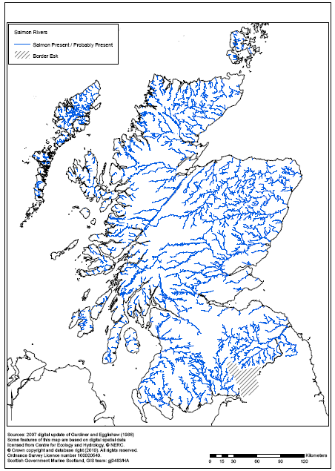

Other Freshwater Species

* + 1. Riverine habitats are also used by other species:
* Those that are legally protected, e.g. otters, freshwater pearl mussels. The flow of clean-well-oxygenated water through river gravels is an important habitat for freshwater pearl mussels.
* Exposed gravels are used by many protected Red List invertebrates. More silted bars are colonised by aquatic macrophytes and invertebrates[[13]](#footnote-13).
* Rivers and lochs support a wide range of bird species, e.g. kingfisher, grey heron, coot, dipper, and moorhen. Some areas are used by over-wintering ducks and geese or for breeding e.g. by red-throated diver.
* River banks are particularly important for species such as water voles and sand martins.
  + 1. In freshwaters, otters feed mainly on fish such as trout, salmon and eels; predation on stillwater fisheries can sometimes be a serious problem for managers. Solution usually lie with appropriate stock protection measures.[[14]](#footnote-14)

Designations

* + 1. Atlantic salmon are protected at both international and European level:
* The Convention for the Conservation of Salmon in the North Atlantic Ocean (1982) established the North Atlantic Salmon Conservation Organization (NASCO), which seeks to promote the conservation, restoration, enhancement and rational management of salmon stocks through international consultation and cooperation, taking into account the best scientific evidence available.
* Atlantic salmon are now included on the OSPAR list of threatened and/or declining habitats and species[[15]](#footnote-15), in all the areas where it occurs (OSPAR regions I, II, III and IV).
* The Convention on the Conservation of European Wildlife and Natural Habitats (1979) (the Bern Convention) regulates the exploitation of the animal species identified in Appendix III to the convention. Atlantic salmon are listed in Appendix III, in fresh water only. At a European level, the Habitats Directive[[16]](#footnote-16) implements the Bern Convention; Atlantic salmon (in fresh water only) are listed in Annexes II[[17]](#footnote-17) and V[[18]](#footnote-18) of the Directive.
* There are 17 Special Areas of Conservation (SACs) for Atlantic salmon in Scotland (Figure 4.2). Of these, 11 are designated with salmon listed as a primary qualifying interest. These SACs apply to fresh water only.
  + - * 1. Locations of SACs in Scotland designated for Atlantic Salmon[[19]](#footnote-19)

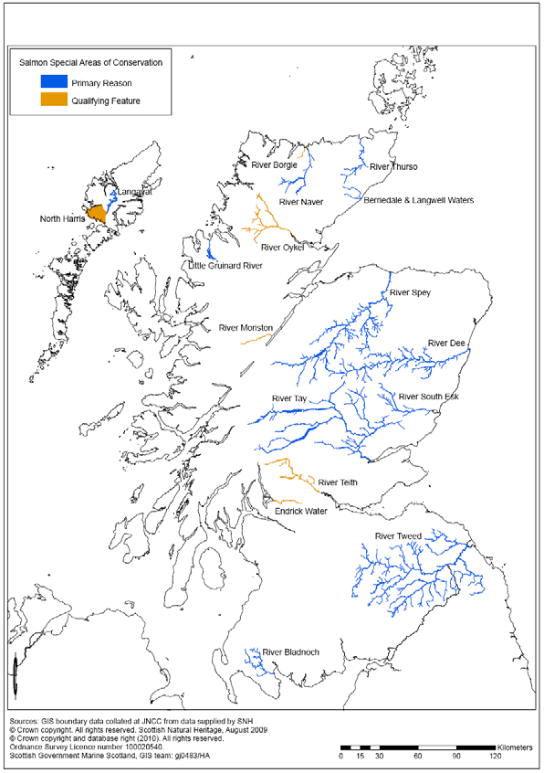

* + 1. Atlantic salmon are a priority marine feature, in terms of the marine component of their lifecycle, in Scottish territorial waters (SNH/JNCC/ Marine Scotland, 2014). Atlantic salmon (the MSW component) is identified as a priority species in the UK Biodiversity Action Plan, following the review of priority species and habitats in 2007 .
    2. The widespread decline in European eels has led the European Commission has develop an Eel Recovery Plan (Council Regulation No 1100/2007), which. aims to return European eel stocks (adults and juveniles) to sustainable levels. Each Member State is required to establish national Eel Management Plans; Scotland’s Eel Management Plan was developed in 2008. The Freshwater Fish Conservation (Prohibition on Fishing for Eels) (Scotland) Regulations 2008 make it an offence to fish for or take eels of the species *Anguilla Anguilla* (any method at any time) except under the authority of a licence granted by the Scottish Ministers. The European eel was also added to the UK BAP Priority Species List in 2007.
    3. Other species of freshwater fish native to Scotland are protected at European or national levels (Table 4.1).
       1. Protected Freshwater Fish in Scotland

|  |  |
| --- | --- |
| Species | Protection |
| Arctic charr[[20]](#footnote-20) | * a conservation feature in five Sites of Special Scientific Interest (Lochs Eck, Insh, Builg, Girlsta and Doon). * present in a number of waterbodies protected by the Natura 2000 network or National Nature Reserves. * added to the UK Biodiversity Action Plan Priority Species List in 2007. |
| grayling | * protected from over exploitation through their inclusion in Annex V of the EU Habitats Directive and Appendix III of the Bern Convention. * listed in the European Habitats Directive as a species of Community interest whose taking in the wild and exploitation may be subject to fisheries management measures |
| sparling[[21]](#footnote-21) | * conservation feature in two Sites of Special Scientific * included in the UK Biodiversity Action Plan Priority Species list. |
| trout | In 2007 both ancestral brown trout forms and sea trout were added to the UK Biodiversity Action Plan Priority Species List. |

* + 1. Other species using freshwater habitat are also protected. For example, otters are classed as European Protected Species under the Conservation (Natural Habitats etc) (Scotland) Regulations 1994 as amended; these protect both otters and their resting places. Core areas of otter habitat are included in the Natura 2000 network (through their inclusion in Annex II of the Habitats Directive). There are currently 44 Special Areas of Conservation in Scotland which have been selected for their otter interest. Otters are also included on the UK BAP species list.
    2. All wild birds in the UK are protected under the Wildlife and Countryside Act 1981 (as amended). Special Protection Areas also provide protection for some of the species using freshwater habitat for breeding and/or overwintering.
    3. Water vole are protected under the Wildlife and Countryside Act 1981 (as amended). Freshwater pearl mussels are also protected in this way; in addition, their habitat is protected by Special Areas of Conservation, of which there are 19 in Scotland.
  1. Water

Policy Context

* + 1. Scotland has a high quality water environment which is important for health and well-being; supports a rich diversity of wildlife; attracts visitors; and provides for the sustainable growth of our economy.
    2. The Water Framework Directive (WFD), implemented through the Water Environment and Water Services (Scotland) Act 2003 (WEWS), requires the introduction of a holistic source-to-sea approach for the management of the water environment. The Scottish Government has extended this principle of integration to its policy and legislative framework, by taking steps to ensure that WFD aims and principles are embedded in all relevant policy and regulatory areas.
    3. The aim in implementing the WFD in Scotland is to achieve an effective balance between the protection of Scotland's water environment and the interests of those who depend upon it for their prosperity and quality of life.
    4. Some areas of the water environment are under considerable pressure from human activity. The WFD introduced a system of river basin management planning to identify and address these pressures.

River Basin Management Plans

* + 1. River basin management planning is a process of water resource management in river basin districts. It was introduced for the first time by the WFD and the WEWS Act. The process involves defining specific environmental objectives for each water body and identifying and implementing a programme of measures to deliver those objectives.
    2. There are two River Basin Management Districts in Scotland: the Scotland district, and the Solway and Tweed district. River Basin Management Plans (RBMPs) were published for both districts in 2009, with ten Area Management Plans published between 2009 and 2011[[22]](#footnote-22). Both were updated in 2015.

Ecological Status of Rivers and Lochs

* + 1. The ecological status of surface waters is an expression of the quality of the structure and functioning of surface water ecosystems, as indicated by the condition of a number of ‘quality elements’[[23]](#footnote-23):
* biological quality (water plants and animals);
* chemical and physicochemical, e.g. oxygen and nutrient levels;
* hydromorphological, e.g. water flows and levels; the condition of beds, banks and shores; and the continuity of rivers for fish migration.
  + 1. There are five classes of ecological status, defined in terms of how much the ecological quality deviates from natural conditions: high, good, moderate, poor or bad.
    2. The ecological status of Scotland’s surface waters in 2014 is provided in Figure 4.3; ecological status figures are provided for rivers/lochs and estuaries in Figure 4.4. More than half of Scotland’s rivers and lochs are of good or higher ecological status. Just under one-quarter are moderate; approximately one-fifth are poor or worse. About 85% of estuaries are of high or good ecological status. The pressures underlying this status are summarised, for all surface waters, in Figure 4.5. More information about pressures on fish movement are provided in Figure 4.6.
       - 1. Ecological status of Scottish surface waters (2014)

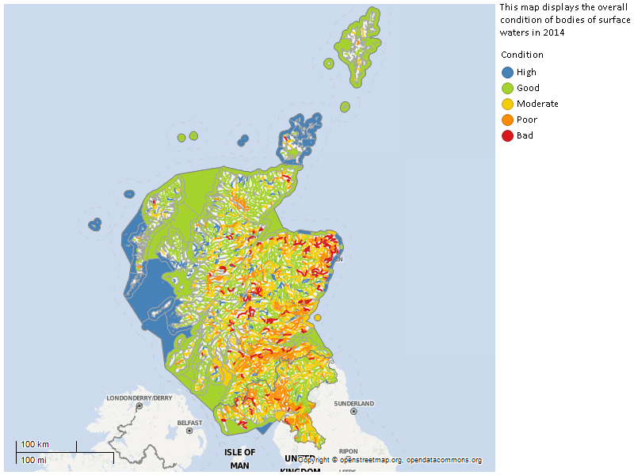

* + - * 1. Surface Waters Classification (2014): (a) Rivers and Lochs (b) Estuaries

(a) (b)

|  |  |
| --- | --- |
|  |  |

* + - * 1. Pressures Affecting Scotland’s Surface Waters

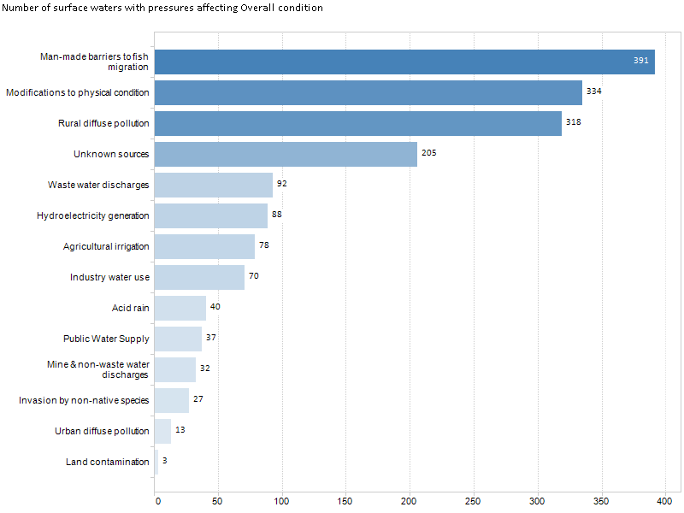

* + - * 1. Access for Fish Migration (a) condition (b) location of pressures (2014)[[24]](#footnote-24)

(a) (b)

|  |  |
| --- | --- |
| \\scotland.gov.uk\dc2\FS4_Home\u202776\Wild Fisheries Reform\environmental report\access for fish migration 2014.png | \\scotland.gov.uk\dc2\FS4_Home\u202776\Wild Fisheries Reform\water\fish migration pressures.png |

* 1. Human Health

Policy Context

* + 1. A key goal of the Scottish Government is to tackle health inequalities, while also seeking to improve diet, increase physical activity and support people to achieve and maintain a healthy weight (Scottish Government, 2008 and 2010). The importance of this goal is highlighted in *A Stronger Scotland: The Government’s Programme for Scotland 2015-16* (p. 64)*.*

General

* + 1. The population of Scotland was estimated at 5,347,600 in 2014, an increase of 19,900 people on the previous year. The majority of people live in central Scotland, whilst the lowest population density is in the Highlands and Western Isles. The population of Scotland is projected to rise to 5.76 million by 2035. The Scottish Government has set a target of matching the average European (EU-15) population growth over the period from 2007 to 2017.
    2. The Scottish Index of Multiple Deprivation (SIMD) ranks small areas (datazones) from the most deprived to the least deprived. It analyses data for a number of indicators across the domains of income, employment, health, education, skills and training, housing, geographic access and crime. The mapping of the Scottish Index of Multiple Deprivation (Figure 4.7) shows the spatial concentration of disadvantage in urban areas of Scotland, particularly west central Scotland, but also other areas. Rural areas are also potentially disadvantaged in some places, particularly when the criterion focusing on access to services is taken into account.
    3. The mental well-being of adults in Scotland averaged a score of 50 between 2006 and 2011 (the score can range between 14 and 70, with a higher score indicating better wellbeing).
    4. Access to the outdoors can provide opportunities for exercise with benefits for physical and mental health and well-being, including reducing obesity and combating stress. The number of adults who made at least one recreational visit to the outdoors was around 78% between 2005 and 2008 with the most commonly visited areas being parks and open spaces (37% of visits). Whilst some 50% of people overall have local greenspace within five minutes of their home, this figure is 39% in deprived areas. Greenspace provides a key opportunity for direct contact with the natural environment, particularly in urban areas, and this has measurable physical and psychological benefits.
    5. Findings from the Scottish Health Survey 2010 for the adult population found that 44% of the population had participated in sporting activities in the previous four weeks. This decreased with age, from 68% of those aged 16-24 down to 13% of those aged 75 and over. Common activities for adults include working out at the gym, doing exercises, swimming and running/jogging.
       - 1. Scottish Index of Multiple Deprivation (2012)

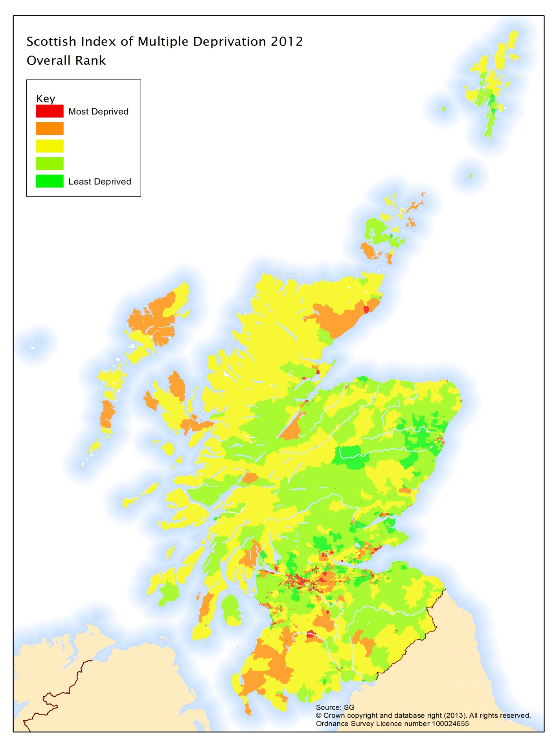

Angling/ Angler Activity

* + 1. In Scotland, sports participation statistics show that around 3% of adults (16+ years) and 3% of children (8-15 years) took part in angling during the most popular two months of each year (these figures are for 2006-2008). Based on 2008 population figures for Scotland of 5,168,500, this equates to 155,055 participants (which has remained fairly constant since 1987) (Brown et al 2012, p.14).
    2. Anglers may or may not be members of angling clubs or associations. Key overarching organisations comprise the Scottish Anglers National Association (SANA), the Scottish Federation of Sea Anglers (SFSA) and the Scottish Federation for Coarse Angling (SFCA). These three have created a partnership to form The Angling Development Board of Scotland (ADBoS). [[25]](#footnote-25)
    3. Recent research in England and Scotland (Brown et al., 2012) on the contribution of angling to health and well-being has identified the following benefits:
* Contributions to physical health, through increasing levels of physical activity and through assisting in recovery from illness and/or injury.
* Contributions to mental health, through promoting positive mental health and through assisting treatment and recovery from mental illness.
* Contributions to improved social well-being, through more time spent with family and friends, and contributing to the wider community through volunteering.

1. Existing Environmental Pressures
   1. Salmon and Sea Trout
      1. There is a wide range of factors which, in combination, might affect production of salmon in fresh water and subsequent survival at sea. These are described further in Figure 5.1 and could include:

* exploitation by marine, coastal and freshwater fisheries
* climate change
* availability of food in both marine and freshwater
* by-catch of salmon in marine fisheries
* inadequate water quality
* physical degradation of spawning and nursery habitat
* physical barriers to migration
* introduction of non-native invasive species
* effects of stocking
* effects of aquaculture
* predation
* diseases and parasites
  1. Non-migratory Salmonids/Other Freshwater Fish Species
     1. Existing environmental pressures on non-migratory salmonids and coarse fish species could include (Figure 5.2):
* exploitation by freshwater fisheries
* climate change
* physical barriers to movement
* introduction of non-native species
* effects of aquaculture, e.g. through outbreaks of freshwater sea lice
* predation
* diseases and parasites
* inadequate water quality (e.g. eutrophication; acidification including from afforestation)
* physical changes to water courses/ physical degradation of spawning and nursery habitat (e.g. river/lake engineering)
  + - * 2. Existing Pressures on Atlantic Salmon (Note: a larger version of this figure is available[[26]](#footnote-26) )



* + - * 1. Existing pressures on non-migratory salmonids and coarse fish



1. Fisheries Management
   1. Introduction
      1. The Salmon and Freshwater Fisheries (Consolidation) (Scotland) Act 2003 (as amended) makes provision for the regulation of salmon and other freshwater fish e.g. methods of fishing (Sections 1 and 2), close times (Sections 13, 17 and 37), etc.
      2. District Salmon Fishery Boards (DSFBs) are responsible for the local management of salmon and sea trout only. At present there are no formally established organisations responsible for the management of other freshwater species, i.e. non-migratory salmonids and coarse fish.
      3. There are 54 Salmon Fishery Districts in Scotland, but only 41 DSFBs at present, including the Tweed Commission (Figure 6.1). Coverage is not provided in the areas shown in white in Figure 6.1 (as previously noted, the Border Esk is managed by the Environment Agency). The DSFBs are supported by Rivers and Fisheries Trusts, who provide scientific advice to them (and others) to inform fishery management. There are also Rivers and Fisheries Trusts in areas where there are no DSFBs, e.g. Loch Lomond, River Clyde.
      4. Pressures on freshwater fish (Section 5) in inland waters may be addressed at the catchment level and/or the local level. Some pressures affecting water quality are likely to be best addressed at the catchment level, which involves coordinated planning and action by the various stakeholders active in that catchment. Other pressures may be more localised, and management measures may reflect this, e.g. dealing with a specific problem such as river bank damage by cattle.[[27]](#footnote-27)
   2. Catchment Level Management
      1. River basin management planning (RBMP) provides a framework for catchment-level management of pressures affecting freshwater fish and fisheries (see Section 4 of this report for further detail). From a freshwater fisheries perspective, these plans play an important role in managing the quality of the environment as well as activities that result in pressures, including:

* the ecological status of water bodies including, but not limited to, water quality
* water abstractions
* obstructions to fish movement
  + 1. For example, the Scotland River Basin Management Plan identifies 238 weirs and dams, and 56 other man-made structures[[28]](#footnote-28) that prevent or restrict fish migration or movement in the district’s river systems.
       - 1. District Salmon Fishery Board Boundaries

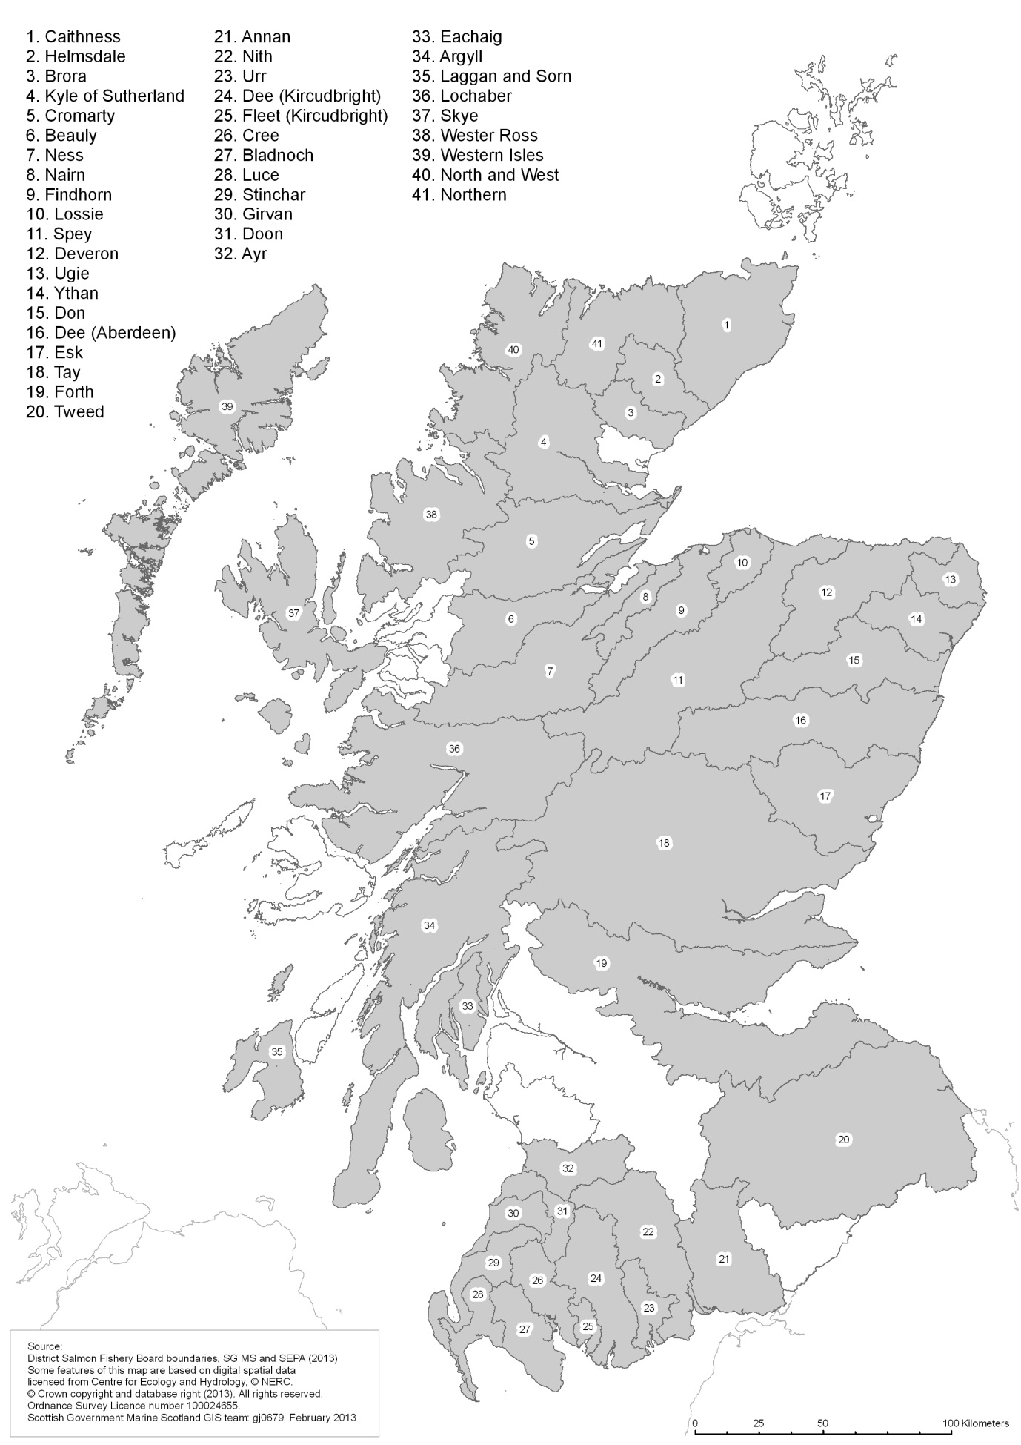

Border Esk

* + - * 1. Area Advisory Groups

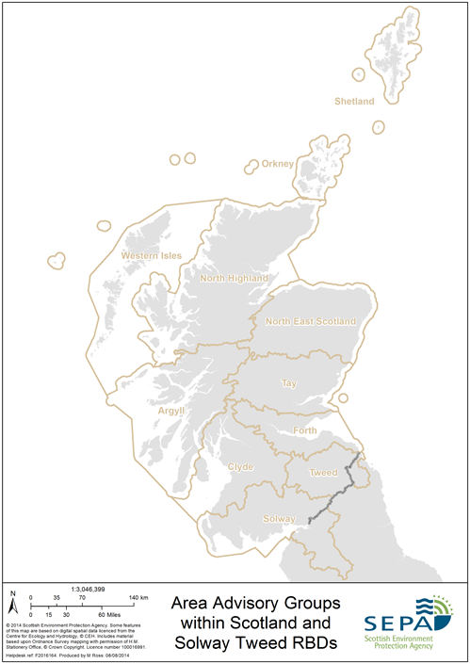

* + 1. Area Advisory Groups were created to contribute to the development and delivery of river basin planning within their respective areas. There are eleven multi-stakeholder Area Advisory Groups in the Scotland and Solway Tweed River Basin Districts (Table 6.1 and Figure 6.2).
    2. The area advisory group fora were established to allow a wide body of interests to provide input to and be regularly informed of progress in the river basin planning process. Each group comprises stakeholders whose activities are relevant to river basin management planning in the particular area; an example of such membership is set out in Figure 6.3. The overall role of the area advisory groups was to contribute to the river basin management planning process in their area and the preparation and delivery of their area management plan.
    3. Each group produced an area management plan to supplement the first round of RBMPs and to help to deliver Water Framework Directive requirements of improving all water bodies to good ecological status and preventing any deterioration.
       1. Fisheries management involvement in Area Advisory Groups

| **Area Advisory Group** | **Fisheries management involvement** |
| --- | --- |
| Argyll and Lochaber | Argyll District Salmon Fisheries Board and Trust  Lochaber District Salmon Fisheries Board |
| Clyde | Ayrshire Rivers Trust  Clyde River Foundation (also representing Lomond Rivers Trust)  Doon District Salmon Fisheries Board |
| Forth | Forth District Salmon Fisheries Board |
| North East | Dee District Salmon Fishery Board  Spey District Salmon Fishery Board |
| North Highland | Cromarty Firth Fisheries Board  Kyle of Sutherland Fisheries Board |
| Orkney | Orkney Trout Fishing Association |
| Outer Hebrides | Outer Hebrides Fisheries Trust |
| Shetland | Shetland Anglers Association |
| Solway | Eden Rivers Trust  Galloway Fisheries Trust |
| Tay | Esk District Salmon Fisheries Board  Tay District Salmon Fisheries Board |
| Tweed | River Tweed Commissioners |

* + 1. The RBMP process was also informed by the Fish and Fisheries Advisory Group, comprising representatives from the Association of Salmon Fishery Boards, River and Fishery Trusts of Scotland, Marine Scotland, Scottish Government (Water Environment), SNH, Environment Agency (as a corresponding member) and the academic sector.[[29]](#footnote-29)
    2. The Argyll and Lochaber area management plan noted that “the river basin planning process must link to, and reflect the requirements of, other plans and processes including flood management and climate change”. These groups therefore need to be integrated and coordinated, particularly when it comes to communication, to facilitate effective catchment planning.
  1. Fisheries Management at the Local Level
     1. Many of the DSFB areas have fisheries management plans prepared jointly by the DSFBs and Fisheries Trusts. These plans define the core work of the Board and Trust, recognising their role in delivering wider policy as well as local initiatives. They coordinate the work of the DSFBs and Fisheries Trusts, both with one another and with fishery owners, anglers, volunteer groups and key agencies in the catchment.
        + 1. Stakeholders in Argyll and Lochaber Area Advisory Group



* + 1. Such plans typically[[30]](#footnote-30) deal with actions relating to:
* climate change
* human exploitation
* man-made obstructions
* diffuse pollution
* invasive species and pathogens
* predation and disease
* education; encouraging new participants
* development, pollution, morphology and abstraction
* access, recreation and communication
* woodland management
* improving infrastructure
* inshore environment and fisheries
  1. Environmental Effects of Fisheries and Habitat Management and Practices
     1. Guidance has been produced on managing river habitats for fisheries (e.g. SEPA, no date; Association of Rivers Trusts, no date). The guidance focuses on the need to consider the wider environment when undertaking such management, in line with the principles and requirements of the Water Framework Directive. The documents emphasise the need to identify the causes of problems, rather than their symptoms, prior to progressing the planning and design of river-based measures, as well as consideration of the potential consequences of management intervention – on river habitat upstream and downstream, on other species and habitats, and on other river users.
     2. The SEA has identified both benefits and adverse consequences of fisheries and habitat management and practices.
     3. These practices can result in benefits for the wider environment, in terms of biodiversity and the ecological status of water bodies. For example, increases in water levels/flows, and improvements in water and sediment quality, would have benefits for species such as freshwater pearl mussels. Improvements in water quality would benefit aquatic invertebrates; an increase in those which form part of the food chain for freshwater fish would be a benefit for those species as well. In turn, increases in freshwater fish populations would benefit piscivorous fish, mammals and birds. However, some management practices may adversely affect the wider environment. It is envisaged that these effects would be identified and mitigated as part of the development of national and local fisheries management plans.
     4. Examples of unintended consequences include are set out in the bullet points below. Note, however, that many of these require licensing under the Water Environment (Controlled Activities) (Scotland) Regulations 2011, as amended (“CAR”).
* Management which seeks to alter channel characteristics such as width, depth, flow velocities and sediment characteristics, or modify the structure of the riparian corridor, may affect the ecological status of a river and/or damage protected species.
* Scotland’s rivers are dynamic by nature, with large flood flows and naturally high erosion rates, which inevitably involves the deposition and erosion of sediment in river channels and the consequent modification of physical habitat. In consequence, action to manage erosion in one part of a river is likely to move the problem elsewhere, upstream or downstream, rather than resolving it.
* Bank stabilisation using hard solutions is likely to exclude freshwater species using the habitat created by eroding river banks, e.g. kingfishers, sand martin, water voles, etc.
* Placement of boulders and/or woody debris in the river channel –e.g. to improve fish cover/refuge - can result in bank erosion or excessive bed scour if not placed correctly.
* Pool management: excavation of pools can cause bed scour (through removal of the protective “armour” layer) and, possibly, channel instability; inappropriate disposal of excavated material may have adverse landscape and/or amenity effects; inappropriate siting of in-channel boulders or structures can result in accelerated bank erosion.
* The removal of accumulated fine sediments through, e.g. raking or flushing using compressed air – is likely to result in them settling out downstream and contributing to degradation of spawning areas.
* Management of bankside vegetation can disturb and/or destroy bat roosts, bird nests, otter holts etc.
* Management of in-channel vegetation may cause downstream accumulation of cuttings and/or colonisation and establishment in new areas, depending on the type of vegetation.
* Improvement of angler access: for example, clearance of bankside vegetation may reduce shade provision, with subsequent increases in temperature etc, and increase bank erosion; removal of woody debris to improve casting may affect invertebrate numbers.
  + 1. Non-native invasive species often outcompete native species, and spread to form dense stands which not only offer little or no habitat for native wildlife species but also tend to leave the river banks unprotected in the winter months and vulnerable to erosion. The management of non-native invasive species requires species-specific measures which may include the use of herbicides or other chemicals, with implications for water quality. Again, the use of herbicides requires a licence under CAR.
    2. The afore-mentioned guidance notes that management should take account of fish species other than Atlantic salmon and of other species using riverine habitat such as otter and freshwater pearl mussel.
    3. Maitland (1992) identified several fishery management practices considered to have adverse implications for freshwater fish conservation, including:
* introduction and/or stocking of non-native species (see paragraph 4.1.6), with effects of outcompeting native fish, introduction of disease and/or parasites, loss of genetic integrity of the local native stock (e.g. brown trout), changes in ecosystems (e.g. effect of ruffe on powan in Loch Lomond).
* removal of unwanted species (including poisoning, netting, trapping, electro-fishing and drainage) which, in its extreme forms, can damage whole waterbody ecosystems or, in its less extreme forms, capture fish other than the target species
  + 1. The use of fish stocking is now strictly controlled, due to the need to protect native biodiversity from the consequences of stocking non-native fish into Scottish fresh waters. Legislation[[31]](#footnote-31) came into force on 1 August 2008 regulating the introduction (i.e. stocking) of all species of freshwater fish within Scotland. It applies to all stocking of freshwater fish, including Atlantic salmon, trout and coarse fish, to any inland Scottish water system apart from within fish farms (including stocking of brood-stock into hatcheries), or to ornamental fish-keeping facilities such as garden ponds.
    2. Scottish Government policy on introductions[[32]](#footnote-32) provides further guidance on:
* introduction of: salmon, sea trout and brown trout; Arctic charr (also vendace and powan); rainbow trout; and coarse fish and species considered to be outwith their native range;
* introductions above impassable natural barriers; and
* introductions into naturally fishless lochans.
  + 1. The use of poison to manage unwanted species is now regulated (Maitland, 2013) and no longer a common practice.

1. Environmental Effects
   1. Introduction
      1. An initial review of the potential environmental effects of the draft policy instruments identified the following:

* the potential benefits to human health, through increased access to and participation in outdoor recreation;
* the continuing benefit to biodiversity, flora and fauna – including but not limited to freshwater fish species – resulting from habitat management and species conservation activities. There may also be benefits from seeking to apply freshwater fisheries management across the whole of Scotland, and to all freshwater fish species.
* possible benefits to water quality and resources, including the ecological status of water bodies, from improved communications and integration of activities between the different agencies, organisations and stakeholders involved in freshwater fisheries and catchment management activities. This would build on the good work already being undertaken through involvement in e.g. river basin management planning.
  + 1. The remainder of this section sets out the results of the assessment of the draft Bill provisions and the draft national strategy.
  1. Draft Bill Provisions
     1. The results of the assessment of each of the draft Bill provisions are summarised in Table 7.1. Taken together, the draft provisions would result in:
* benefits to biodiversity and the ecological status of water bodies; and
* a mix of benefits to human health.

Biodiversity

* + 1. Many fisheries management practices, including habitat management, may provide benefits for species other than freshwater fish (see Section 6 of this report). The draft provisions relating to promotion of the conservation of freshwater fish in wild fisheries and their habitats, and best practice in the management of wild fisheries (Sections 1 and 9), would therefore have benefits for the wider environment, in terms of biodiversity and the ecological status of water bodies.
    2. A key benefit for freshwater fish is the extension of freshwater fisheries management to include all freshwater fish species, across the whole of Scotland. Why is this a benefit? Mainly because the extension of management to cover all of Scotland should lead to a consistency of management, including of all species, across the whole country. The focus of management would change from being predominantly salmon- and sea trout-centred to ensure that the interests of all freshwater species and their habitats are taken into account. Management would therefore be provided to relieve the pressures on non-migratory salmonids and coarse fish (identified in Section 5.2), as well as those affecting migratory salmon and sea trout. It would also regulate management practices that benefit one species to the detriment of another without due consideration. Such management would include (and thereby benefit) aquatic species that are of conservation rather than commercial value, such as lamprey (sea, river and brook) and eels.
    3. The overarching duty for Scottish Ministers would be progressed in the context of existing environmental legislation and policy, particularly that relating to biodiversity and the ecological status of water bodies (Figure 2.1). Accordingly, any actions progressed to further this overarching duty would necessarily take these wider issues into account e.g. during the strategy and/or national plan development. In consequence, it was considered unnecessary to add wording to the draft provisions to capture these issues.[[33]](#footnote-33) Recognition of these issues could also be made explicit in the wording of the draft national strategy.
    4. Like Scottish Ministers, FMOs would be required to consider the implications of their activities for the good ecological status of water bodies, through the requirements of the Water Environment and Water Services (Scotland) Act 2003. However, FMOs would not be public bodies, as defined by the Scottish Government[[34]](#footnote-34). In consequence, the biodiversity duty is not directly applicable to their activities. However, Scottish Ministers are empowered to provide guidance to FMOs, and the need to take wider biodiversity into consideration would be emphasised in this guidance, for example, when developing local fisheries management plans required by Section 10. These plans require Scottish Ministers’ approval.
    5. The requirement for Scottish Ministers to prepare a national strategy would provide similar biodiversity benefits, since the national strategy would set out Ministers’ objectives, priorities and policies for achieving their overarching duty – to set the framework for management planning by both national and local management bodies. The requirement to regularly review the strategy would assist its updating if monitoring identified unanticipated or adverse environmental effects, or benefits that could be enhanced. The same biodiversity benefit would ensue from the requirement for FMOs to prepare local fisheries management plans (Section 10).
    6. The powers for regulation set out in Sections 23, 24, 27 and 28, taken together, could be of benefit to freshwater fish populations which in turn could have wider biodiversity benefits. The provisions for enforcement (Section 36) would have similar benefits, as enforcement supports regulations whose objective is to protect and/or conserve freshwater fish.
    7. Section 25 would provide for Scottish Ministers to make conservation regulations about activities that exert pressure on freshwater fish. This would be of biodiversity benefit, as it would contribute to the resolution of catchment-wide pressures on freshwater fish and their habitats, with consequent wider biodiversity benefits.
    8. Section 26 would provide powers for Scottish Ministers to require, through regulations, data collection and evaluation. Data collection would support the evidence base needed for appropriate fisheries management strategies and practices. This would also be of biodiversity benefit, for the reasons cited in preceding paragraphs.

Water

* + 1. Given that many fisheries management practices, including habitat management, may provide benefits for species other than freshwater fish, these would support water bodies in attaining good or higher ecological status, in line with Scottish Government objectives and the requirements of legislation. This would likely include stream substrates, given their importance for spawning and the provision of shelter in early life cycle stages. However, as noted in paragraph 7.2.2, some management practices may adversely affect the wider environment. It is envisaged that these effects would be identified and mitigated as part of the development of national and local fisheries management plans.

Human Health

* + 1. The duty to promote conservation would only be of indirect benefit to human health, through ensuring maintenance of the resource upon which angling depends.
    2. The framework for a wild fisheries levy, set out in Section 22, has the potential for adverse effects on human health. Stakeholders have expressed concerns about the potential for the levy to result in new and/or increased costs to fishery owners, and that these would be passed on to anglers. There are fears that these costs would be such that anglers would leave the sport, which would work against objectives to increase participation in angling, with the benefits that such participation could bring. However, these effects may be offset by the actions within the draft strategy to promote access to and opportunities for angling (see paragraph 7.3.11).
  1. Draft National Strategy
     1. The SEA has considered the elements of the draft strategy: the vision; the overarching objectives; and the strategic framework. The results of the assessment of the strategic framework are set out in Table 7.2.

Vision

*To protect, develop and enhance social and economic benefit from Scotland’s freshwater fish and fisheries; and to promote access to fishing opportunities and participation.*

* + 1. The draft vision focuses on the social and economic benefits of fishing, including those arising from increased access to and participation in angling. A prerequisite for the success of the vision is a fishery that is sustainable in the long-term – the goal of the duties set out in Sections 1 and 9 of the draft Bill provisions. However, the vision is silent on this point, despite the remainder of the draft strategy including objectives, themes and indicators which set out to achieve this.
    2. On that basis, this could be mitigated by amending the wording of the vision to explicitly include reference to the wider environment. For example, the wording could read “to protect, develop and enhance *environmenta*l, social and economic benefit …”. This would provide the “green thread” to run through the remainder of the policy and planning hierarchy, including at the FMO level.

Key Overarching Objectives

* + 1. The key overarching objectives build on the vision and set the scene for the strategic framework. As with the vision, it is important for the objectives to make clear that environmental quality should be a key consideration within the policy and planning hierarchy. In consequence, the wording of the objectives could be amended to explicitly include environment. A suggestion would be:
* Providing comprehensive protection and improvement of Scottish freshwater fish and the habitats they depend on, *in a sustainable manner*.
* Promoting effective, evidence-based fishery management through integrated data gathering, research and dissemination.
* Identifying and maximising societal benefits from sustainable fisheries, and the promotion of *sustainable* angling as a recreational and tourism activity.

Strategic Framework

* + 1. The strategic framework builds on the vision and overarching objectives, and identifies four themes for action:
* protecting and growing the resource
* science and research
* partnership and engagement
* promotion
  + 1. A key action is to identify pressures on fish, their habitats and species and to prioritise and take pragmatic action where sensible. These actions would be integrated with existing processes, including for example river basin management planning. They would therefore reflect other catchment-level national priorities, including: achieving good or higher ecological status in water bodies; the control of non-native invasive species; and the removal of physical obstacles to fish movement.
    2. At this stage we envisage that the “pragmatic actions” would be progressed through inclusion in the national management plan and/or local fisheries management plans. Management practices are likely to be beneficial for aquatic ecosystems, as well as for freshwater fish species. However, some may adversely affect other aspects of aquatic and terrestrial ecosystems. The consequences to the wider environment of the actions in these plans would be subject to SEA at both the national and local level. Any environmental effects would be identified and appropriate mitigation measures identified through this process.
    3. The indicators for national enforcement (1.3) and data collection (2.1, 2.2, 2.3) would have benefits for both biodiversity and the ecological status of water bodies since, taken together, they are intended to address gaps in the evidence base that supports fisheries management practices, as well as supporting regulations whose objective is to protect and/or conserve freshwater fish.
    4. The indicators for partnership and engagement (3.1 and 3.2) would normally be considered to be procedural and therefore screened out of the SEA. However, the nature of the pressures on freshwater fisheries and the need for communication and coordination between the many stakeholders involved, means that continuing and building on partnership working at the national and local levels would be of benefit both to freshwater fisheries and the wider environment. These are therefore considered to be of benefit for both biodiversity associated with these indicators are essential to achieve national strategy would set out Scottish Ministers’ objectives, priorities and policies for achieving their overarching duty (i.e. the conservation of freshwater fish in wild fisheries and their habitats, and the management of wild fisheries).
    5. The promotion of angling, including improved access to and participation in angling, would have benefits for human health, as increased physical activity has potential benefits for both physical and mental health. Participation in angling is also considered to have wider social and community benefits in terms of improved engagement by family and community members, which in turn is positive for mental health.
       1. Draft Bill Provisions: SEA Results

|  |  |  |
| --- | --- | --- |
| SEA Objectives | Key: environmental effects | |
| Obj 1 – Biodiversity | Work against SEA objective |  |
| Obj 2 – To maintain or work towards good ecological and environmental status | No change |  |
| Obj 3 – To safeguard human health | Mixed effects |  |
|  | Promote SEA objective |  |
|  | Uncertain |  |

| Draft bill provisions | | Biodiversity | Human health | Ecological status | Comments |
| --- | --- | --- | --- | --- | --- |
| 1 | overarching duty SM |  |  |  | Management practices are likely to be beneficial for aquatic ecosystems, as well as freshwater fish species. However, some may adversely affect other aspects of aquatic and terrestrial ecosystems. See Section 6 of this report and paragraph 7.2.4. |
| 2 | national strategy |  |  |  |
| 3 | strategy review |  |  |  | Would assist updating if monitoring identified environmental effects. |
| 6 | FMAs |  |  |  | Extends fisheries management to all of Scotland, as well as to all freshwater fish species. |
| 9 | overarching duty FMOs |  |  |  | Management practices are likely to be beneficial for aquatic ecosystems, as well as freshwater fish species. However, some may adversely affect other aspects of aquatic and terrestrial ecosystems. See Section 6 of this report and paragraph 7.2.5. |
| 10 | local fisheries management plan |  |  |  |
| 22 | wild fisheries levy |  |  |  | Stakeholders have raised concerns about costs being passed on to anglers, with potential adverse effects on human health. However see also paragraph 7.3.10 re the national strategy. |
| 23 | conservation regulations |  |  |  | Would continue powers to make certain fisheries management practices statutory, e.g. close times, equipment types. |
| 24 |  |  |  |
| 25 | structures/obstructions etc |  |  |  | Would contribute to the resolution of catchment-wide pressures. |
| 26 | data collection |  |  |  | Data collection would support the evidence base needed for appropriate fisheries management strategies and practices. |
| 27 | tagging |  |  |  | Controls taking and killing of freshwater fish – important for rivers where population levels are not sustainable. |
| 28 | licensing |  |  |  |
| 36 | enforcement |  |  |  | Supports enforcement of regulations whose objective is to protect and/or conserve freshwater fish. |

* + - 1. Draft National Strategy: SEA Results

|  |  |  |
| --- | --- | --- |
| SEA Objectives | Key: environmental effects | |
| Obj 1 – Biodiversity | Work against SEA objective |  |
| Obj 2 – To maintain or work towards good ecological and environmental status | No change |  |
| Obj 3 – To safeguard human health | Mixed effects |  |
|  | Promote SEA objective |  |
|  | Uncertain |  |

| Draft national strategy | | Biodiversity | Human health | Ecological status | Comments |
| --- | --- | --- | --- | --- | --- |
| 1.1 | habitat protection/restoration |  |  |  | Management practices are likely to be beneficial for aquatic ecosystems, as well as freshwater fish species. However, some may adversely affect other aspects of aquatic and terrestrial ecosystems. |
| 1.2 | national and local priorities and plans |  |  |  | Management practices are likely to be beneficial for aquatic ecosystems, as well as freshwater fish species. However, some may adversely affect other aspects of aquatic and terrestrial ecosystems. |
| 1.3 | national enforcement |  |  |  | Mostly procedural but enforcement officer role includes specific responsibilities and accountability for ensuring compliance. |
| 2.1 | coordination/planning of research projects and priorities |  |  |  | Data collection would support the evidence base needed for appropriate fisheries management strategies and practices. |
| 2.2 | establish research and data collection priorities |  |  |  | Data collection would support the evidence base needed for appropriate fisheries management strategies and practices. |
| 2.3 | national data standards |  |  |  | Data collection would support the evidence base needed for appropriate fisheries management strategies and practices. |
| 3.1 | partnership working |  |  |  | Integrated working likely to be more effective in taking forward catchment-level planning and ensuring consistency of management across species and rivers/water bodies. |
| 3.2 | policy development - interactions |  |  |  | Integrated working likely to be more effective in taking forward catchment-level planning and ensuring consistency of management across species and rivers/water bodies. |
| 4.1 | promotion of angling |  |  |  | Increased physical activity has potential benefits for physical and mental health and well-being and social/community engagement. |

1. Conclusions, Consultation and Next Steps
   * 1. It is worth noting that many of the freshwater fisheries management activities are already taking place in many areas. However, the draft policy instruments provide an opportunity to extend these to the whole of Scotland, across all freshwater fish species, and to provide improved integration and communication between the various agencies, organisations and stakeholders involved in freshwater fisheries management. Taken together, the draft policy instruments are likely to result in benefits to biodiversity, the ecological status of water bodies, and human health. However, some management measures – if carried out without due consideration and/or required licences – have the potential to give rise to adverse effects on biodiversity and ecological status. At this stage we envisage that SEA will be required of both the national fisheries management plan and the local fisheries management plans. The potential environmental effects of fisheries and habitat management practices would be identified and mitigated through SEA of these plans.
     2. The consultation document and the Environmental Report have been published for public consultation. The consultation period will close on 2 May 2016.
     3. The Bill and national strategy are likely to be submitted to the Scottish Parliament in late 2016/early 2017.
        1. **Draft Bill and National Strategy: Key Facts**

|  |  |
| --- | --- |
| Responsible Authority | Scottish Government/Marine Scotland |
| Title | Draft provisions for a Wild Fisheries (Scotland) Bill / Draft Wild Fisheries Strategy |
| Purpose | To consult on draft clauses for inclusion in the future Bill and on the draft outline of the future national strategy |
| Drivers | Wild Fisheries Review; Habitats Directive |
| Subject | Management of Scottish freshwater fisheries |
| Period covered | 2016/2017 onwards |
| Frequency of updates | The national strategy will be reviewed on a 5-year cycle. |
| Area covered | Scottish coastal and inland waters |
| Nature/ content | draft legislation and policy |
| Proposed objectives? | The key overarching objectives of the draft strategy are provided. |
| Date | February 2016 |
| Contact | Amanda Chisholm  tel. 0131 244 7806; email: [amanda.chisholm@gov.scot](mailto:amanda.chisholm@gov.scot)  Jeff Gibbons  tel: 0131 244 6066; email: [jeff.gibbons@gov.scot](mailto:jeff.gibbons@gov.scot) |

1. References

Association of Rivers Trusts. No date. Rural River Habitat Management: best practice recommendations for use in agricultural areas by Rivers Trusts and River Improvement Groups.

Brown, A., Djohari, N., and P Stolk. January 2012. Fishing for Answers: The Final Report of the Social and Community Benefits of Angling Project. Substance, Manchester. Available from: <http://resources.anglingresearch.org.uk/>

Fisheries Research Services. 2004. Scotland’s Freshwater Fish Populations: Introductions and Movements.

Maitland, Peter S. September 2013. Management of Wild Fisheries in Scotland: a Baseline Report.

Maitland, Peter S. 1992. Fish and angling in SSSIs in Scotland.

Marine Scotland. April 2015. Proposed conservation measures to introduce a licensing system for killing wild salmon in Scotland: Environmental Report. Available from: <http://www.gov.scot/Topics/marine/Salmon-Trout-Coarse/fishreform/licence/status>.

Marine Scotland. 2010. Scotland’s Freshwater Fish Populations: Introductions and Movements. Topic Sheet No. 30 V1.

Scottish Environment Protection Agency. No date. Managing River Habitats for Fisheries. Published by SEPA for a working group of representatives from the Fisheries Research Services Freshwater Laboratory, the Fisheries Branch of the Scottish Executive Environment and rural Affairs Department, SEPA and Scottish Natural Heritage.

Scottish Executive. 2002. A Guide to Public Bodies in Scotland. Available from: <http://www.gov.scot/Publications/2002/04/gpbs/gpbs>

Scottish Government. May 2015. Wild Fisheries Reform: a response to the report of the Wild Fisheries Review.

Scottish Government. 2015. A Stronger Scotland: The Government’s Programme for Scotland 2015-16. The Scottish Government, Edinburgh. Available from: <http://www.gov.scot/Publications/2015/09/7685/downloads>

Scottish Government. 2014. Implementing the Water Environment and Water Services (Scotland) Act 2003: Assessing Scotland’s water environment – use of environmental standards, condition limits and classification schemes. Policy Statement. Available from: <http://www.gov.scot/Publications/2014/08/7289/downloads#res458328>

Scottish Government. 2010. Healthy Weight Route Map: A long Term Obesity Strategy. Available from: <http://www.gov.scot/Topics/Health/Healthy-Living/Healthy-Eating>

Scottish Government. 2008. Healthy Eating, Active Living: an action plan to improve diet, increase physical activity and tackle obesity (2008-11). Available from: <http://www.gov.scot/Topics/Health/Healthy-Living/Healthy-Eating>

SNH, Salmon and Trout Association, SANA, RSPB: Black-throated divers and Anglers: how you can help Black-throated divers. Available from: <http://www.assyntanglinginfo.org.uk/?q=wildlife>

Thin, Andrew, Hope, Jane and Michelle Francis. October 2014. Report of the Wild Fisheries Review Panel.

1. Appendix 1: Draft Bill Provisions Screening

| **Section** | **Proposed powers/duties** | **Potential for environmental effect?** |
| --- | --- | --- |
| Part 1: Administration and Management of Wild Fisheries | |  |
| 1 | Scottish Ministers’ overarching duty to promote: the conservation of freshwater fish in wild fisheries and their habitats; and best practice in the management of wild fisheries. | Yes. Management practices are likely to be beneficial for aquatic ecosystems, as well as freshwater fish species. However, some management practices may adversely affect other aspects of aquatic and terrestrial ecosystems. |
| 2 | Requires Scottish Ministers to prepare a national strategy; to consult; and to lay the strategy before the Scottish Parliament. The strategy will set out Scottish Ministers’ objectives, priorities and policies for: the conservation of freshwater fish in wild fisheries and their habitats; and the management of wild fisheries. |
| 3 | Sets out the process by which the strategy should be reviewed (on a five-year cycle) and, if appropriate, revised. | Uncertain. The review of the strategy would assist its updating if monitoring identified unanticipated or adverse environmental effects, or benefits that could be enhanced. |
| 4 | Powers for Scottish Ministers to undertake research or inquiries into any matter relating to or affecting wild fisheries and/or freshwater fish in wild fisheries; and to obtain information about these matters. | No. Procedural in nature. |
| 5 | Allows Scottish Ministers to sample or tag fish for identified purposes e.g. research. | No. Procedural in nature. |
| 6 | Places a duty on Scottish Ministers to divide Scotland into areas, to be known as Fisheries Management Areas. | Yes. Extends fisheries management to all of Scotland, as well as to all freshwater fish species. |
| 7 | Identifies estuary limits for rivers in a Fisheries Management Area. | No. Procedural in nature. |
| 8 | Sets out the process by which Fisheries Management Organisations (FMOs) will be designated. | No. Procedural in nature. |
| 9 | Duty of a FMO to promote: the conservation of freshwater fish in wild fisheries in its Area and their habitats; and best practice in the management of those wild fisheries. In discharging that duty, to act in accordance with the National Wild Fisheries Strategy and the Local fisheries Management Plan for its Area. | Yes. Management practices are likely to be beneficial for aquatic ecosystems, as well as freshwater fish species. However, some management practices may adversely affect other aspects of aquatic and terrestrial ecosystems. |
| 10 | Duty on a FMO to prepare a Local Fisheries Management Plan and submit the plan to Scottish Ministers for approval. The Local Fisheries Management Plan will set out FMOs’ objectives and priorities with respect to: the management of wild fisheries in its Area; the conservation of freshwater fish in those areas and their habitats; and the activities to be undertaken. |
| 11 | Requires FMOs to prepare and publish annual reports. | No. Procedural in nature. |
| 12 | Requires FMOs to prepare and publish annual audited accounts. | No. Procedural in nature. |
| 13 | Sets out requirements for FMOs to hold an annual public meeting. | No. Procedural in nature. |
| 14 | Sets out requirements for a complaints procedure. | No. Procedural in nature. |
| 15 | Effect of governance requirements under other legislation. | No. Procedural in nature. |
| 16 | Powers to Scottish Ministers to modify the governance requirements. | No. Procedural in nature. |
| 17 | Powers to Scottish Ministers to issue guidance to FMOs about governance. Duty on FMOs to have regard to such guidance. | No. Procedural in nature. |
| 18 | Powers to Scottish Ministers to investigate FMOs. | No. Procedural in nature. |
| 19 | Powers to Scottish Ministers following such investigations. | No. Procedural in nature. |
| 20 | Allows a decision by Scottish Ministers to revoke a FMO’s designation to be reviewed by an independent person. | No. Procedural in nature. |
| 21 | Powers to Scottish Ministers to provide financial assistance to a FMO. | No. Procedural in nature. |
| 22 | Sets out the framework for a wild fisheries levy. | Uncertain. Although procedural in nature, stakeholders have raised concerns about new and/or increased costs being passed on to anglers, such that anglers would leave the sport – with potential for adverse effects on human health. |
| Part 2: Regulation of Wild Fishing and Fisheries | |  |
| 23 | Power to Scottish Ministers to make conservation regulations for or about the conservation of freshwater fish and/or their habitats, as well as for the protection and management of wild fisheries. | Yes. Would make certain fisheries management practices statutory, e.g. close times, equipment types, fishing methods, etc. |
| 24 | Provision for such regulations to control, amongst others, fishing methods, equipment, locations, timing, catch and release, etc. including prohibition on returning dead fish to the water. | Yes. Would make certain fisheries management practices statutory, e.g. close times, equipment types, fishing methods, etc. |
| 25 | Provision for such regulations to make provision for or about:   * construction/alteration of structures in the water e.g. dams; * alteration/removal of natural obstructions in rivers/estuaries; * alteration of watercourses; or * protection of fish from predators, parasites or disease. | Yes. Would contribute to the resolution of catchment-wide pressures on freshwater fish and their habitats. |
| 26 | Provision for collecting data and evaluating information. | Uncertain. The collection of data would support the evidence base needed for appropriate fisheries management strategies and practices. |
| 27 | Provision for tagging fish. | Yes. Controls taking and killing of freshwater fish – important for rivers where population levels are not sustainable. |
| 28 | Provision for licensing schemes for the taking and killing of freshwater fish. | Yes. Controls taking and killing of freshwater fish – important for rivers where population levels are not sustainable. |
| 29 | Duty on Scottish Ministers to consult affected FMOs and others as appropriate before making such regulations, unless these have been requested by the FMO in question. | No. Procedural in nature. |
| 30 | Process for FMOs to make requests for local measures. | No. Procedural in nature. |
| 31 | Where FMOs have made such a request, duty for FMO to monitor and evaluate the effectiveness of local measures. |  |
| 32 | Sets out offence of contravention of conservation regulations. | No. Procedural in nature. |
| 33 | Makes it a criminal offence to fish for, take or kill any species of fish without legal right of permission. | No. Procedural in nature. |
| 34 | With Schedule 1, prescribes lawful methods of fishing for or taking freshwater fish. | No. Procedural in nature. |
| Part 3: Enforcement | |  |
| 35 | Powers to FMOs and Scottish Ministers to appoint water bailiffs. | No. Procedural in nature. |
| 36 | Exercise of enforcement powers | Yes. Supports enforcement of regulations whose objective is to protect and/or conserve freshwater fish. |
| 37 | Powers of enquiry | No. Procedural in nature. |
| 38 | Powers of entry | No. Procedural in nature. |
| 39 | Wardens | No. Procedural in nature. |
| 40 | Exercise of enforcement powers | No. Procedural in nature. |
| 41 | Powers of enquiry and entry | No. Procedural in nature. |
| Part 4: General | |  |
| 42 | Fish and fisheries: definitions | No. Procedural in nature. |
| 43 | Conservation and management: definitions | No. Procedural in nature. |
| 44 | Other definitions and interpretation | No. Procedural in nature. |
| 45 | Border rivers: the Act would not apply to the River Tweed or the Upper Esk. | No. Procedural in nature. |

1. <http://www.gov.scot/Topics/marine/Salmon-Trout-Coarse/fishreview/WFRFinal> [↑](#footnote-ref-1)
2. The consultation document was subject to pre-screening under the Act (reference PRE\00641 on the SEA Database <http://www.gov.scot/Topics/Environment/environmental-assessment/sea>). [↑](#footnote-ref-2)
3. The consultation analysis report is available from <http://www.gov.scot/Topics/marine/Salmon-Trout-Coarse/fishreform/analysis> [↑](#footnote-ref-3)
4. <http://www.gov.scot/Resource/0048/00484439.pdf> [↑](#footnote-ref-4)
5. More information is available on <http://www.gov.scot/Topics/marine/Salmon-Trout-Coarse/fishreform>). [↑](#footnote-ref-5)
6. This is the seaward limit of a Fisheries Management Area, as defined by Section 6(2) of the draft Bill provisions. [↑](#footnote-ref-6)
7. taken from: Marine Scotland. 2010. Scotland’s Freshwater Fish Populations: Introductions and Movements. Topic Sheet No. 30 V1. [↑](#footnote-ref-7)
8. NASCO Rivers Database Report UK – Scotland (2011); database available at <http://www.nasco.int/RiversDatabase.aspx> [↑](#footnote-ref-8)
9. Available from: <http://www.gov.scot/Topics/marine/Salmon-Trout-Coarse/fishreform/licence/status> [↑](#footnote-ref-9)
10. from SEPA 2002, p. 10 [↑](#footnote-ref-10)
11. ibid [↑](#footnote-ref-11)
12. Source: Scottish Federation for Coarse Angling: <http://www.sfca.co.uk/go-fishing/know-your-fish/> [↑](#footnote-ref-12)
13. ibid [↑](#footnote-ref-13)
14. <http://www.snh.gov.uk/about-scotlands-nature/species/mammals/land-mammals/otters/> [↑](#footnote-ref-14)
15. OSPAR List of Threatened and/or Declining Habitats and Species 2008-6. Available from <http://www.ospar.org/content/content.asp?menu=00730302240000_000000_000000> [↑](#footnote-ref-15)
16. Directive 92/43/EEC on the Conservation of Natural Habitats and of Wild Flora and Fauna [↑](#footnote-ref-16)
17. Annex II of the Habitats Directive identifies animal and plant species of community interest whose conservation requires the designation of Special Areas of Conservation. [↑](#footnote-ref-17)
18. Annex V of the Habitats Directive identifies animal and plant species of community interest whose taking in the wild and exploitation may be subject to management measures. [↑](#footnote-ref-18)
19. Source: Malcolm et al (2010), p.4. [↑](#footnote-ref-19)
20. Source: <http://www.snh.gov.uk/about-scotlands-nature/species/fish/freshwater-fish/charr/> [↑](#footnote-ref-20)
21. Source: <http://www.snh.gov.uk/about-scotlands-nature/species/fish/freshwater-fish/sparling/> [↑](#footnote-ref-21)
22. Source : <http://www.sepa.org.uk/environment/water/river-basin-management-planning/publications/> [↑](#footnote-ref-22)
23. Scottish Government 2014, p. 15 [↑](#footnote-ref-23)
24. Source: SEPA Water Environment Hub <http://www.sepa.org.uk/data-visualisation/water-environment-hub/?riverbasindistrict=Scotland> [↑](#footnote-ref-24)
25. <http://www.adbscotland.org/> [↑](#footnote-ref-25)
26. https://consult.scotland.gov.uk/wild-fisheries-reform-team/draft-wild-fisheries-strategy [↑](#footnote-ref-26)
27. SEPA et al. 2002. p. 3. [↑](#footnote-ref-27)
28. including culverts and roads and railways, and bridge reinforcements [↑](#footnote-ref-28)
29. http://www.sepa.org.uk/environment/water/river-basin-management-planning/who-is-involved-with-rbmp/ffag/ [↑](#footnote-ref-29)
30. This example was taken from the Aberdeenshire Dee & District Fisheries Management Plan 2015-2018. [↑](#footnote-ref-30)
31. Salmon and Freshwater Fisheries (Consolidation) (Scotland) Act 2003, as amended by the Aquaculture and Fisheries (Scotland) Act 2007 [↑](#footnote-ref-31)
32. Policy available from: <http://www.gov.scot/Topics/marine/Licensing/fishintros/introduction> [↑](#footnote-ref-32)
33. In addition, it is not considered good practice to repeat existing legislative requirements in new legislation. [↑](#footnote-ref-33)
34. Bodies which have a role in the processes of national Government, but are not a Government department or part of one, and which accordingly operate to a greater or lesser extent at arm’s length from Ministers. [↑](#footnote-ref-34)